Calculus 3 Lecture 13.2: Limits and Continuity of Multivariable Functions (with Squeeze Th.)

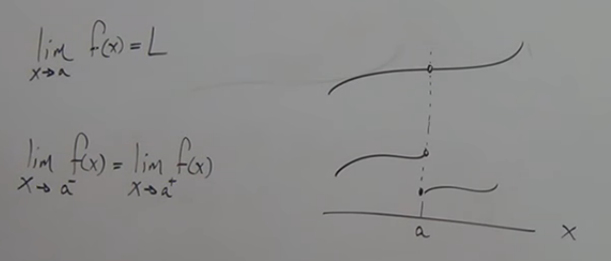
When the independent variable “x” approaches “ a” (travels towards x= “a” from the right and the left along the curve) then the f(x) value from the left must equal the f(x) value from the right.

What about 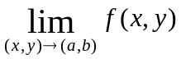

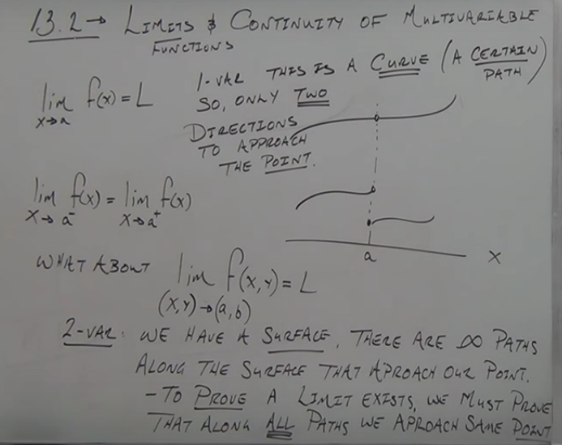
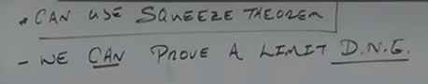
To prove that a limit does not exist by showing that along two paths we get a different value 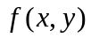as we approach the same point 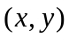
Example
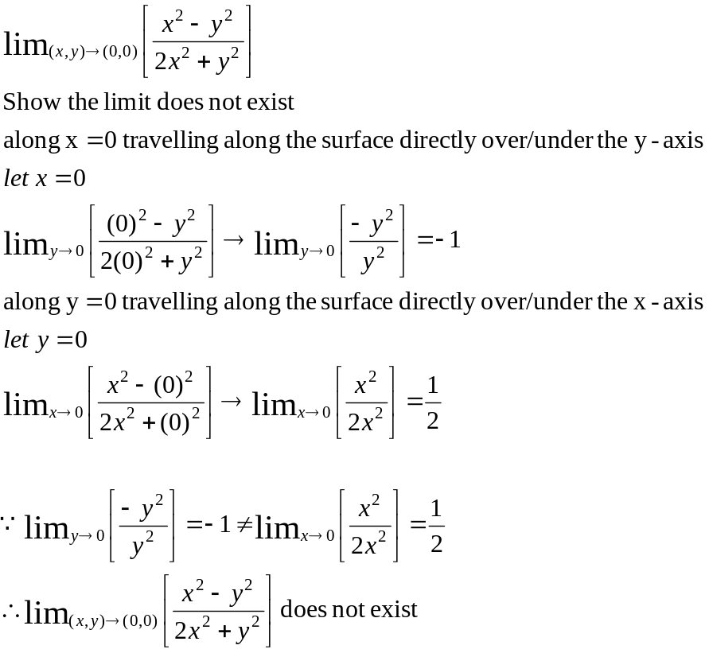

1. Try setting 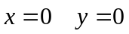 paths first.
- if above does not work choose other paths.
    - Be certain the point  is actually on the path.
    - Try substitution so that the degrees of the numerator and denominator become the same.
    - Always choose either 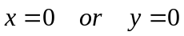as one of the paths.

Example
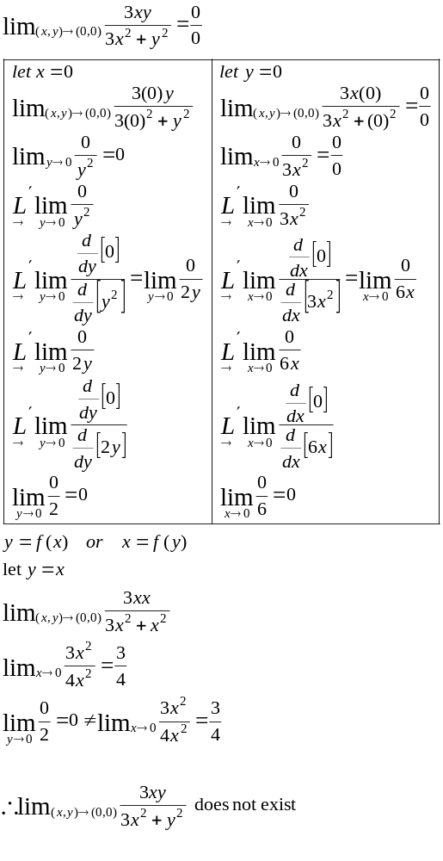

Example
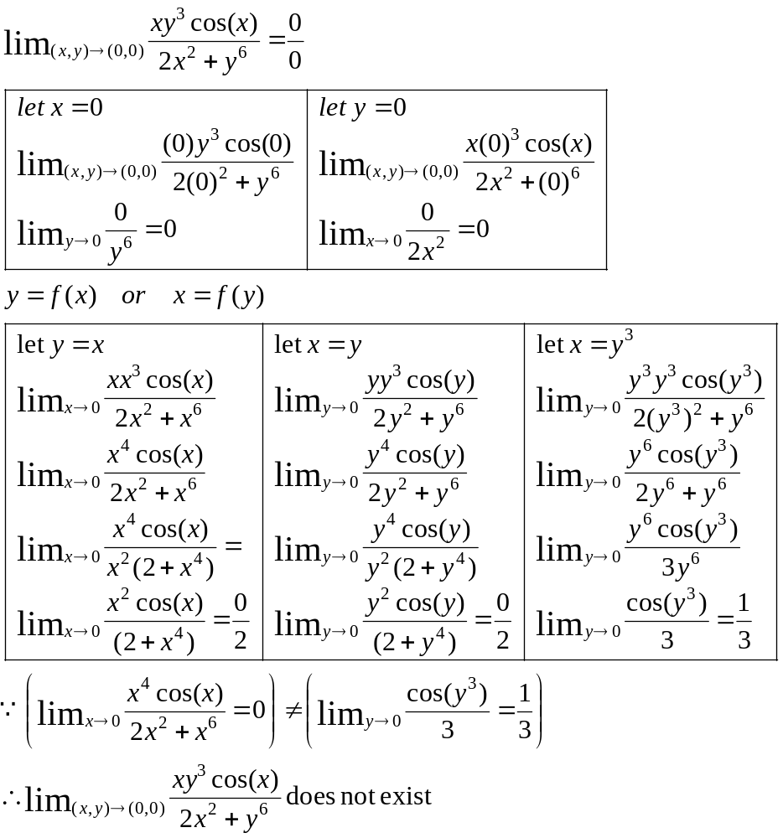

Example
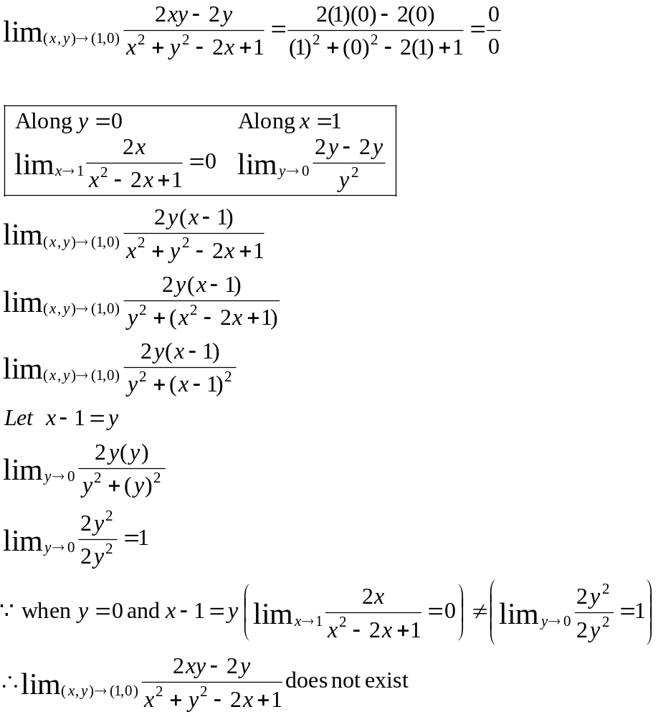

Example
Show 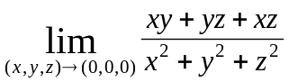 does not exist

- For 3 independent variables, paths are now parametric “t”
- Always choose an axis as a 1st path

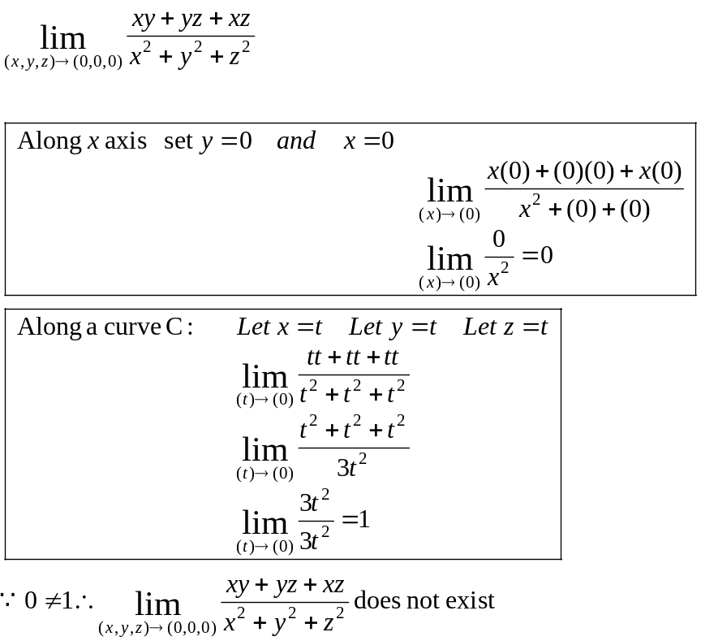
Example
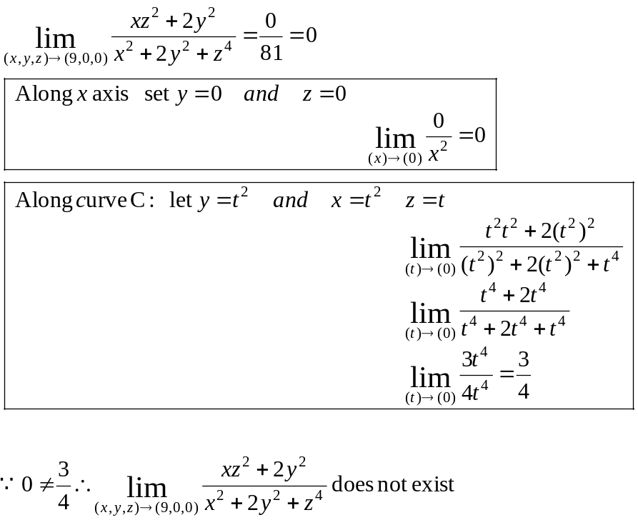
Example
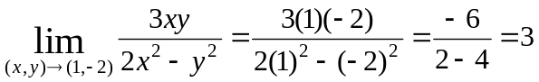

Example
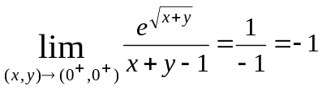

Example
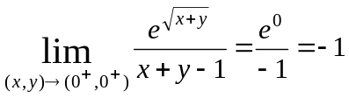

Example
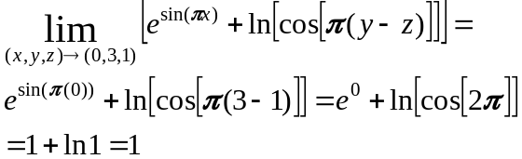

Example
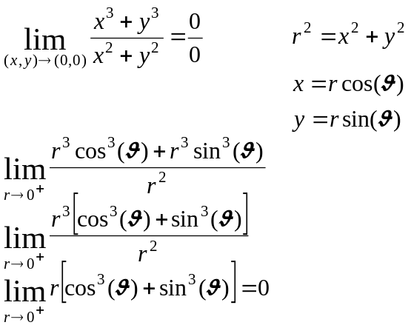

Example

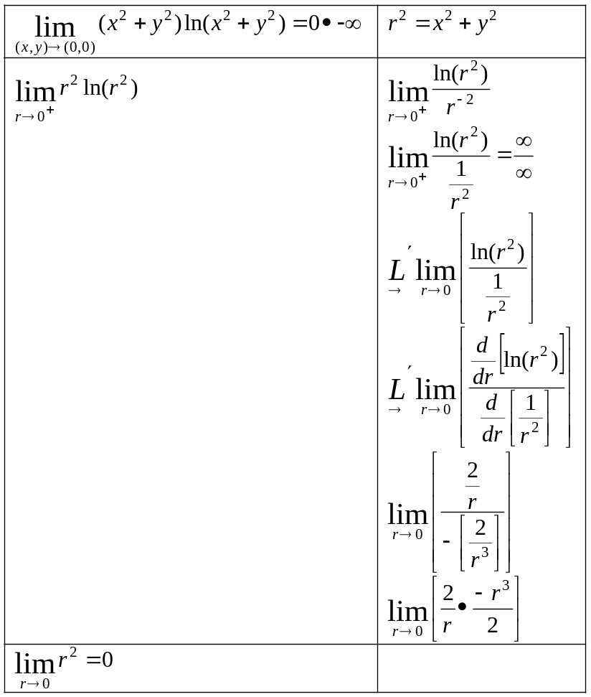

Continuity
A function is continuous at any point on the region for which it is defined. (find the domain).

- Polynomials are continuous everywhere.
- Rational functions are continuous everywhere where the denominator is NOT zero.
- Continuity holds for compositon of functions

Example
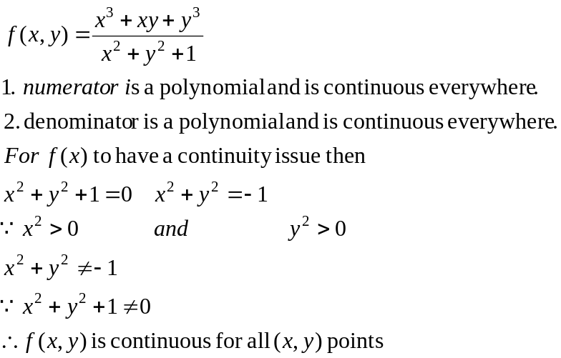

Example
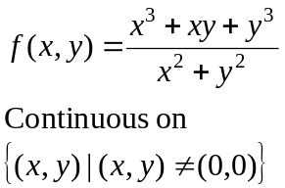

Example
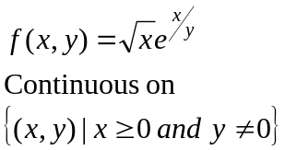

Example
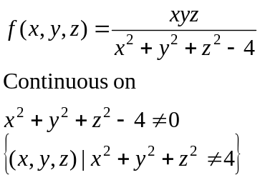

Example
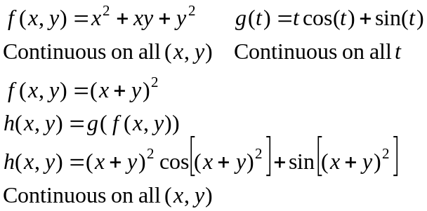

Example
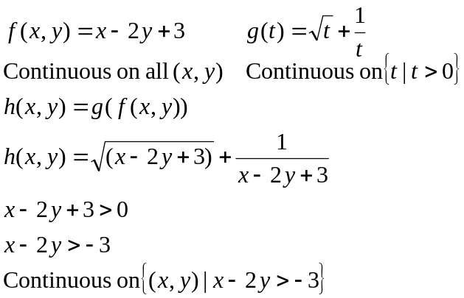

Example
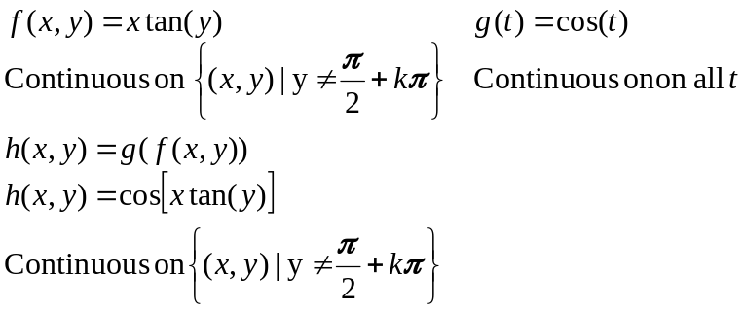

Squeeze Theorem
Example
